Assignment 4

# Meta Analysis

I first run a meta analysis of the data in the literature. I calculate the mean effect size and its standard error across the studies, and use a random intercept by study to find the between-studies variation. The result can be seen below:

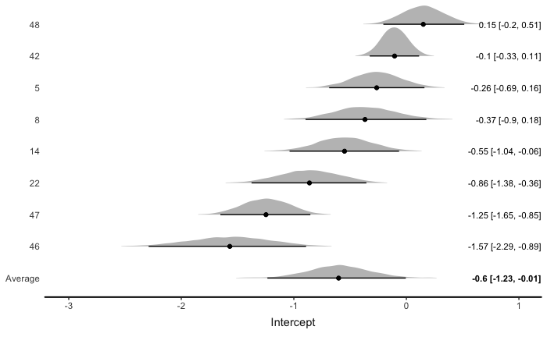

Most effect sizes seem to be reliably below 0, indicating a common effect. There is, though, a noticeable spread in mean effect sizes, indicating the possibility that there the different studies have not measured the same phenomena, or that there have been systematic variations in the data collection. This is also reflected in the numerical output of the model:

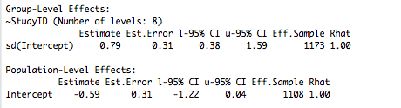

Where the 95% credibility interval just barely overlaps with 0. There is a fairly large standard deviation, compared to the effect size, as was also seen in the spread on the plot.  
Below are plots of the estimated effect size, again showing that even though it does overlap with the zero, the chance of there not being an effect is very slight.

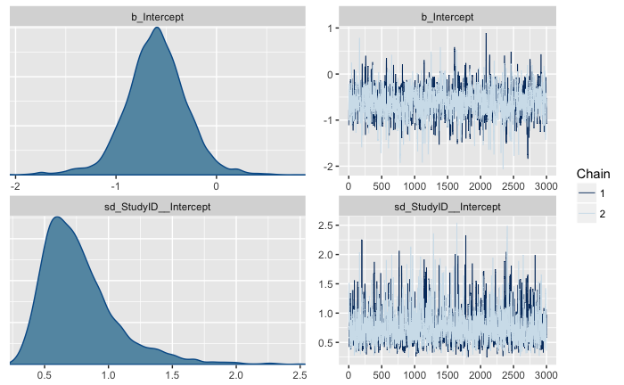

# Analysing own experiment

Using the data supplied from the new experiment, I want to investigate the effect of diagnosed schizophrenia on the variance (in standard deviations) in pitch (in Hz) of a person’s speech.  
All variables have been scaled and centred, and have been averaged over each participant, to avoid having to use a multilevel model (which we haven’t learned yet).  
For the sceptical prior, I use a normal distribution with mean 0 and SD 0.1. For the meta analytical prior, I use a normal distribution with a mean of the estimated mean effect size from the meta analysis, and a standard deviation equal to the standard error from the meta analysis. I could have used the standard deviation instead, so as to reflect the variation between studies, and get a better estimation of the results of my own study. But I use the standard error because I believe that the earlier studies have indeed investigated the same phenomena, and because I am interested in finding the true underlying effect, not simply the best estimates for my own experiment.

Below is a plot of the two priors, sceptic (red) and meta analytical (black). It can be seen that the meta analytical prior is negative, and much broader, than the sceptical prior.

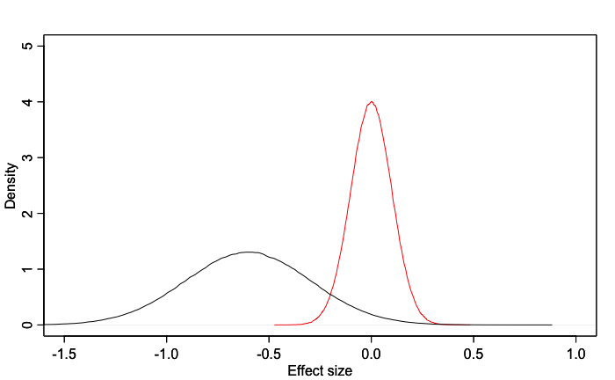

Below are the outputs of the two models:

Sceptical model  
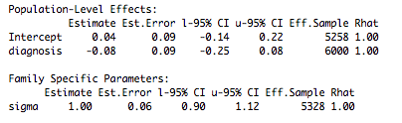  
Meta model  
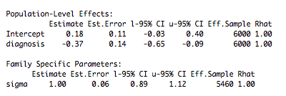

And plots of the estimated intercept, effect of diagnosis, and variance in the model:

(Sceptic prior to the left, meta analytic prior to the right)

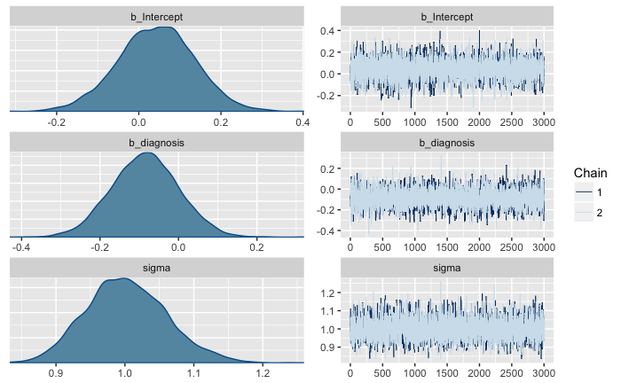 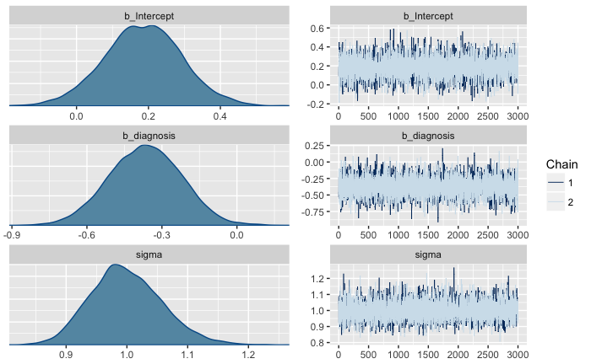

It can be seen that the resulting distributions are very similar in shape, all but the sigma approximating a normal distribution. The sigma distributions with the two priors are almost identical, if only slightly narrower when using the meta analytical prior. The important difference between the two priors is that the effect of diagnosis is more strongly negative (as predicted) when using the meta analytical prior, and that the intercept as a consequence is more positive. This means that neither of the distributions has any relevant overlap with zero, as they do when using the sceptical prior.

# Quality check

The WAIC for both models are almost identical (433.23 for the sceptic prior model, and 433.02 for the meta analytical model), so they seem to predict the data almost equally well. If anything, the meta analytical model is very slightly better, though this could be by chance.

Below is plotted the data (bold line) versus sampled predictive posteriors (light lines) for both models (sceptic left and meta analytical right).

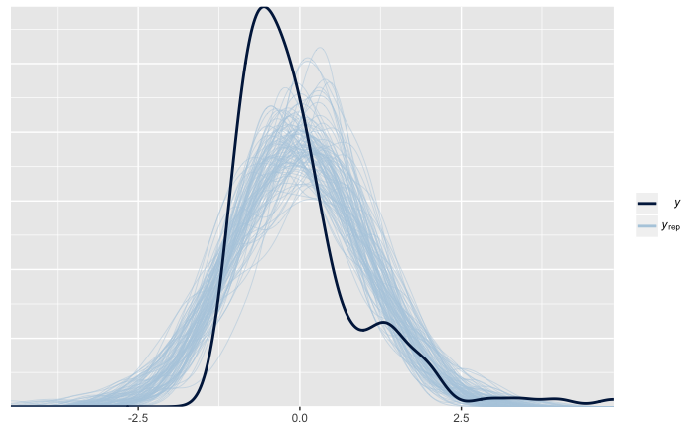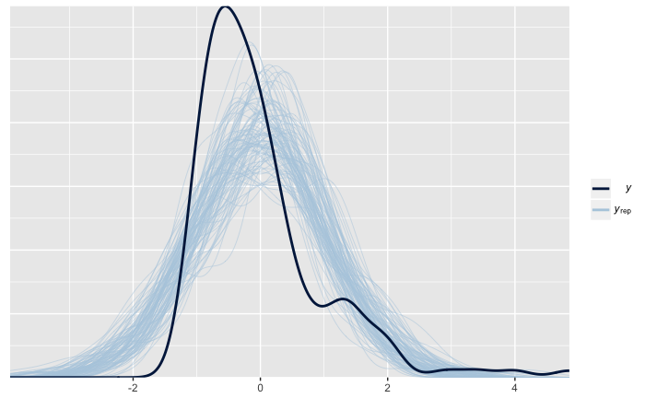

It can be seen that both models misses the first peak, probably to account for the longer right tail than the left. It seems that the predictions are very close to normal, which might be what prevents the model from making good predictions. It should be noted, though, that the model does capture most of the general trend, except for could seem to be two groups with different pitch variance baselines.  
From this plot, both models seem to predict indistinguishably well, which is also reflected in the almost-identical WAIC values.

# The role of meta-analytic priors in scientific practice

Advantages: We can use the information from earlier studies – studies are no longer isolated attempts at understanding but can inform each other. Especially it is important that this process, which happens implicitly through inspiration and cooperation, can now also happen formally and transparently.

Drawbacks: We are more likely to get results that support existing literature. Bad conclusions and false positives can persist, and science as a whole stay more narrow-minded. Also, studies do not always investigate the same phenomena, and some studies are of low quality, meaning that the meta-analytic priors can be misleading.

An option is to use them complimentarily with conservative priors, to see the difference. The choice from there is then always complicated, but at least there are results based on both methods – one on carefulness and one on earlier information.   
 Conservative priors then reflect the scepticism in science – be careful not to be overconfident but build conclusions only on rigorous examination. At the same time, the meta-analytic approach reflects the cumulative, cooperative aspect of science in a formalizable and therefore transparent and controllable way, and is as such an important and powerful tool that should be developed further.